Project Midas User Guide

# Getting Started

* For Midas Version 1, Place a Myo armband on your upper forearm arm



* Connect your Myo armband to Myo Connect (Software from Thalmic Labs)
* Sync with the ‘Myo Sync Gesture’. Do so by holding your wrist waved outwards and moving your arm away from your body.
* Run MidasGUI.exe

# First Glance at the UI

* When you start Midas, something like the following UI will appear:

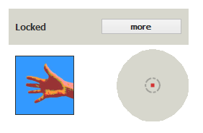

* This shows 3 main parts of the UI
  + The blue square shows your **current gesture** (ie if you spread your fingers, it will show you)
  + The grey circle ‘bulls eye’ shows you how your cursor is being controlled (more on this later)
  + The grey rectangle shows what mode you are in (more later as well)
    - It also has a button that allows you to see more information

# Modes

* Midas has 4 unique modes
  + Locked Mode: You can’t do anything! You can only unlock from here
  + Mouse Mode: Your arm becomes a joystick. Everything is based off of the angle that your arm enters this mode from. If you move your arm up, the red dot will move up and the cursor will start to move up, just like a joystick moving forward. If you move your arm left, the red dot will move left, and so on. Below is a diagram to help show this behavior:

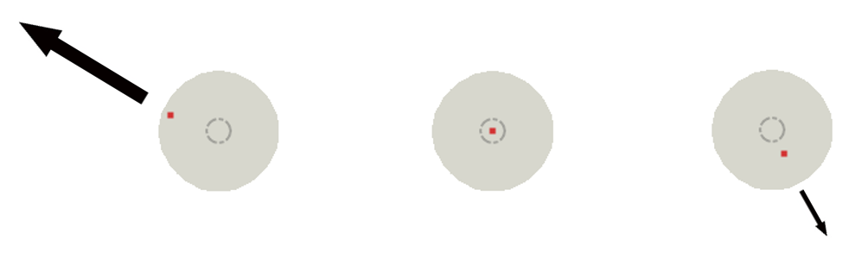

* + Gesture Mode: Your arm no longer acts like a joystick. Instead, Midas is listening for you to perform other actions with hand and arm movements to perform more interesting operations (like changing your volume)
  + Keyboard Mode: Just like in mouse mode, the angle of your arm controls everything. And your fist controls if you choose a letter. If you angle your arm down and to the left like in the image to the left below, then tap your fist, you will type the letter ‘i’. Note that if you **hold** the fist, then you will get the second letter that is highlighted, in this case ‘I’.

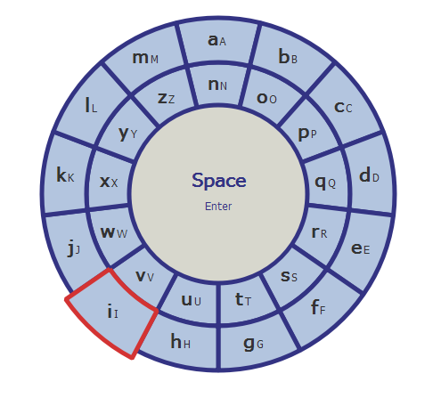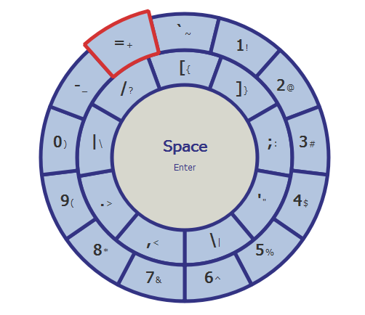

Note that you can also change between the inner and outer ring by swiping right, and change wheels (change to other character sets) by spreading your fingers, as shown in the image above and right.

# Learn More

* The best way to learn is by doing! Click on the ‘more button’ to see **all of your options**.
  + This will expose all of the sequences that you can do to either perform an action or change a state
* For example, when you’re in Keyboard Mode, the following will be shown to you:

